Async_JavaScript 🡪Asynchronous JavaScript (Lecture 2)

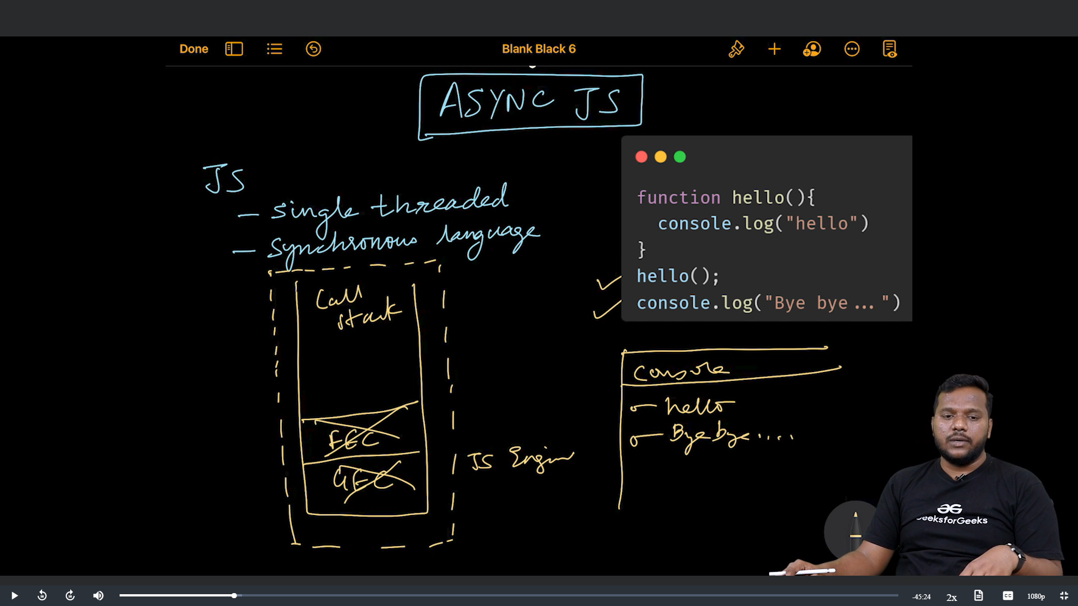

The timer or event Listener or accessing of GPS locations, access to database or access to server these are all coming from browser.

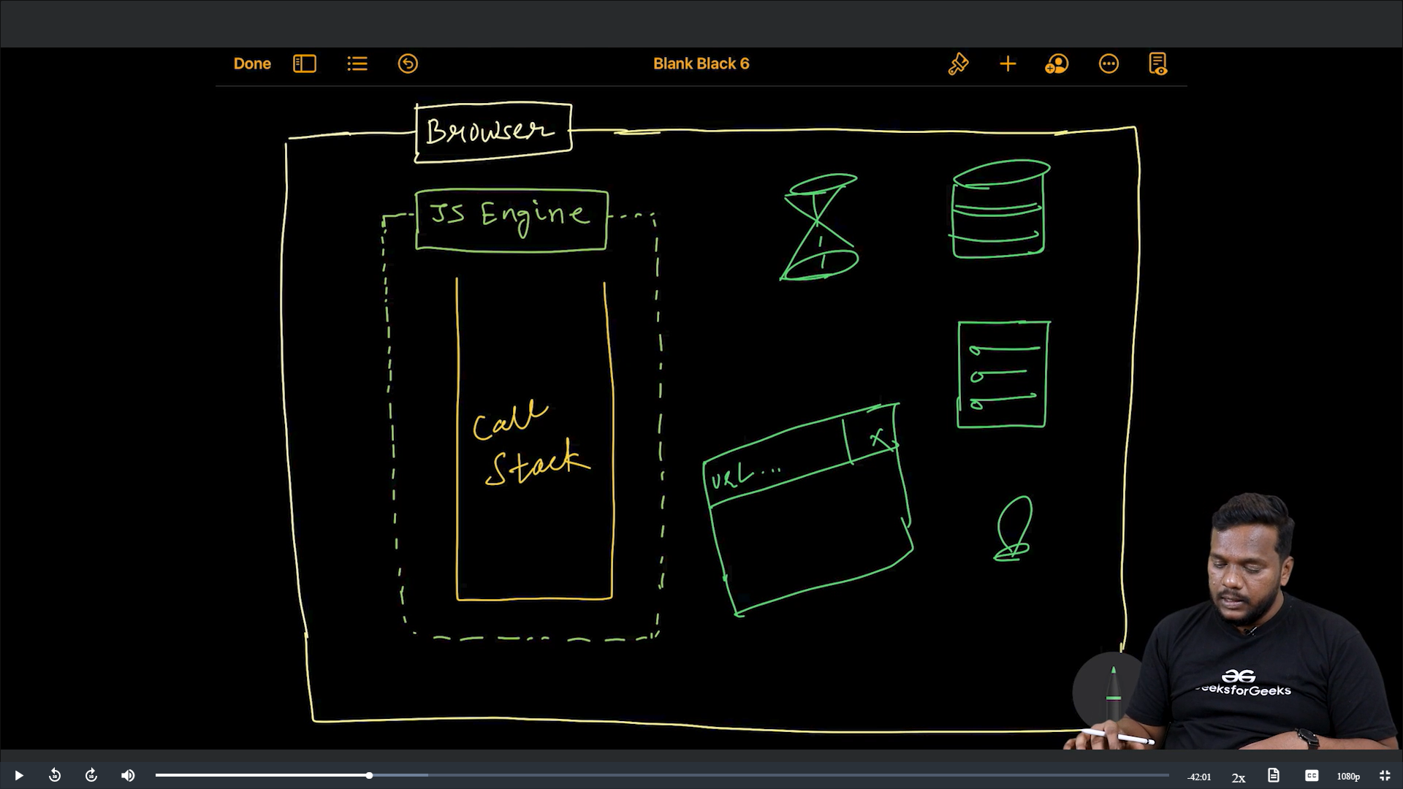

The browser provides access to all these things through Web API.

It consists of DOM, Timer, HTTP Request, Console. So selecting an element through event listeners and all is done by browser as it consists DOM APIs. Even console is also done by the Browser not by the JS Engine.

Whenever we do console.log it basically initiates the console window present inside the developer tools of the browser.

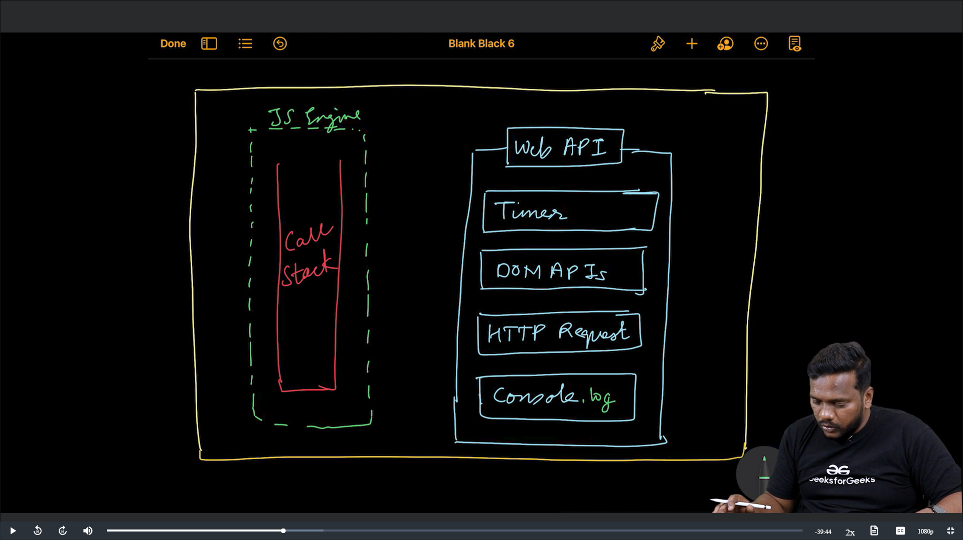

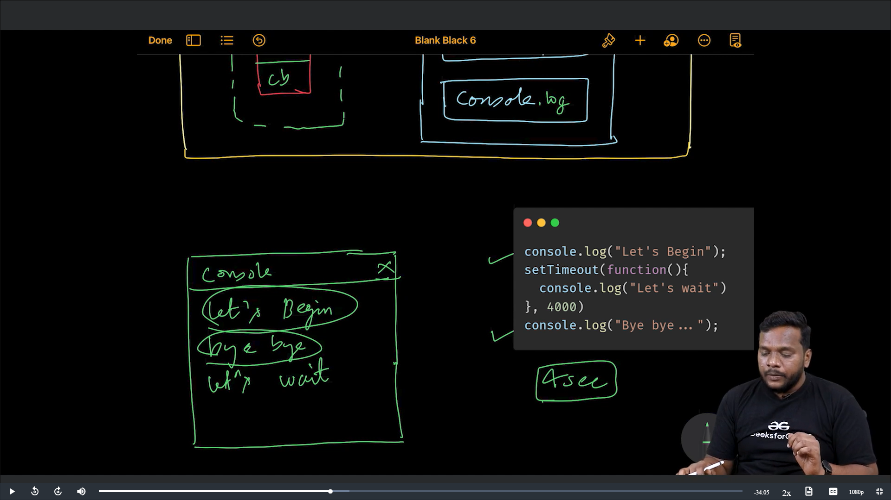

In the browser along with this web APIs there is Event Loop and a Callback Queue.

In the above example, the function is created and stored somewhere initially later once the time is over it is sent to call back queue. Event loop always loops and keeps on monitoring and checks the call stack and once the call stack is empty it checks this callback queue to present other functions which are waiting inside it. So, this in the above example (Bye Bye) is seen before that (Let’s Wait).

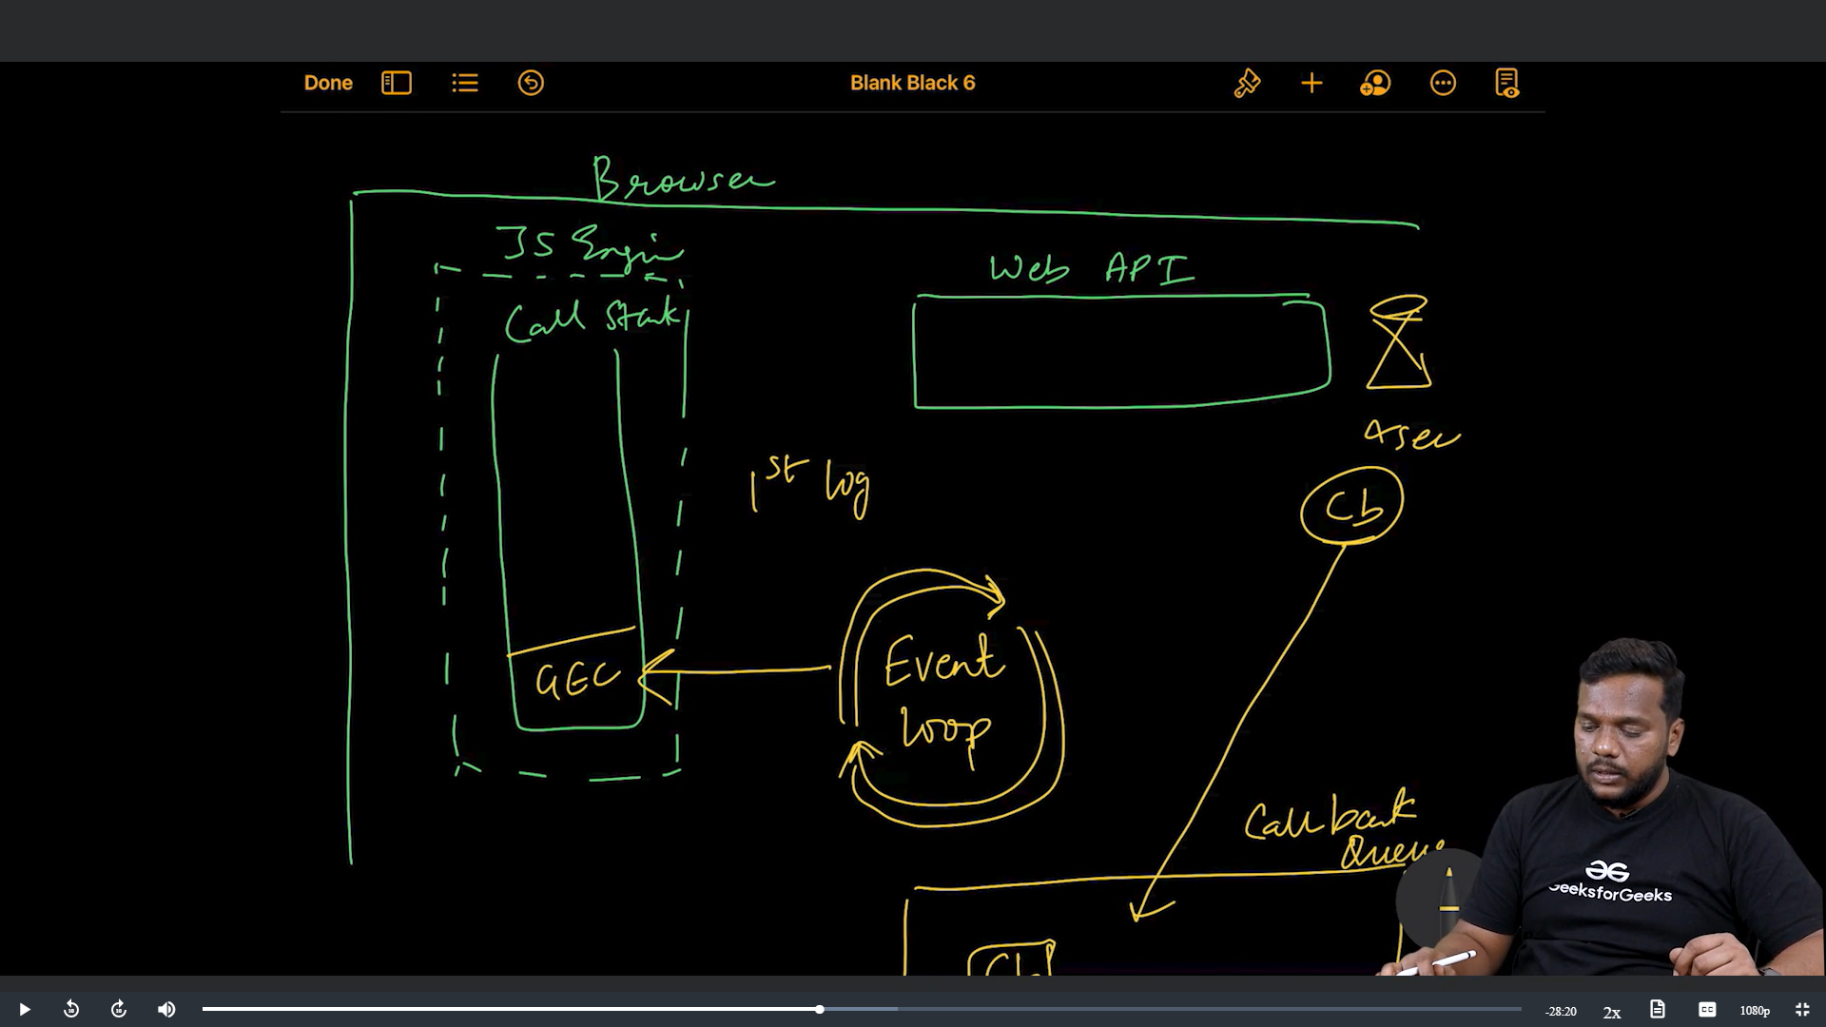

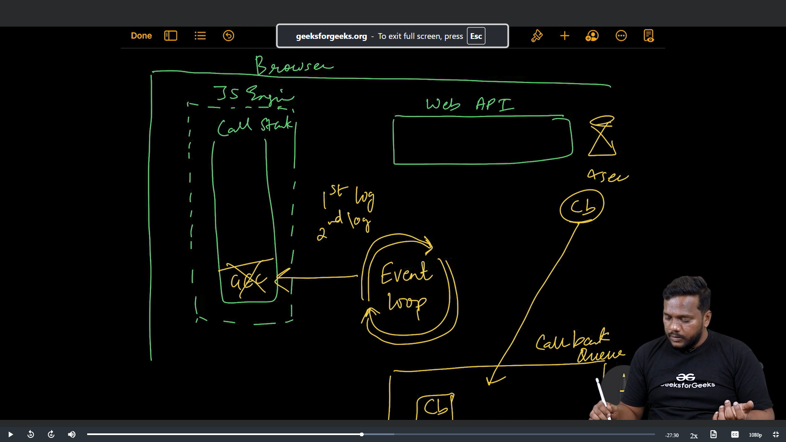

The callback function is sent to callback queue after the completion of time delay.

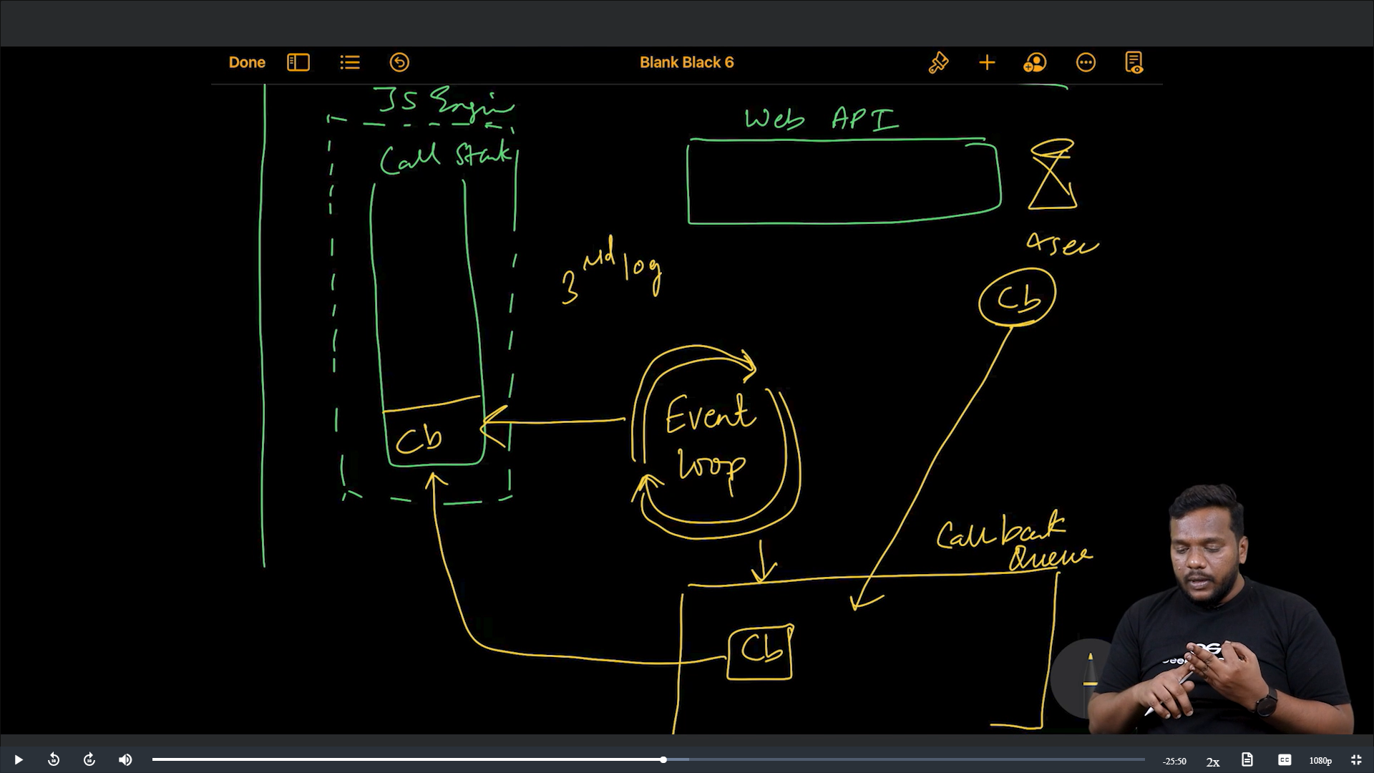

After 1st and 2nd lines of output at last callback function is also executed.

Example:

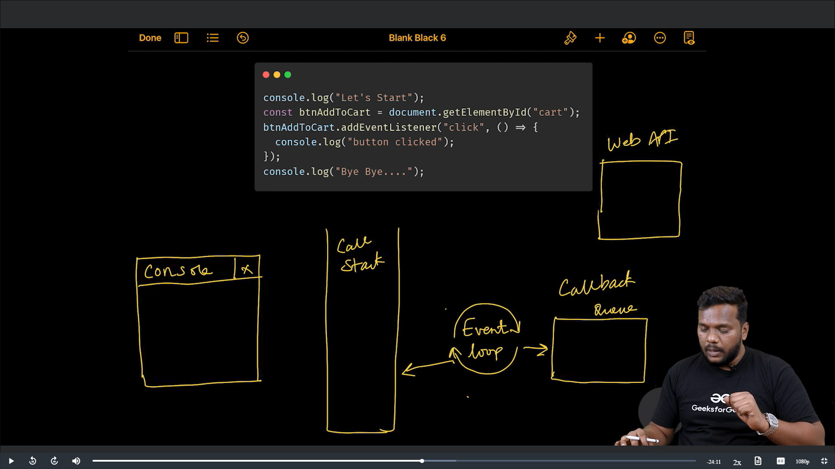

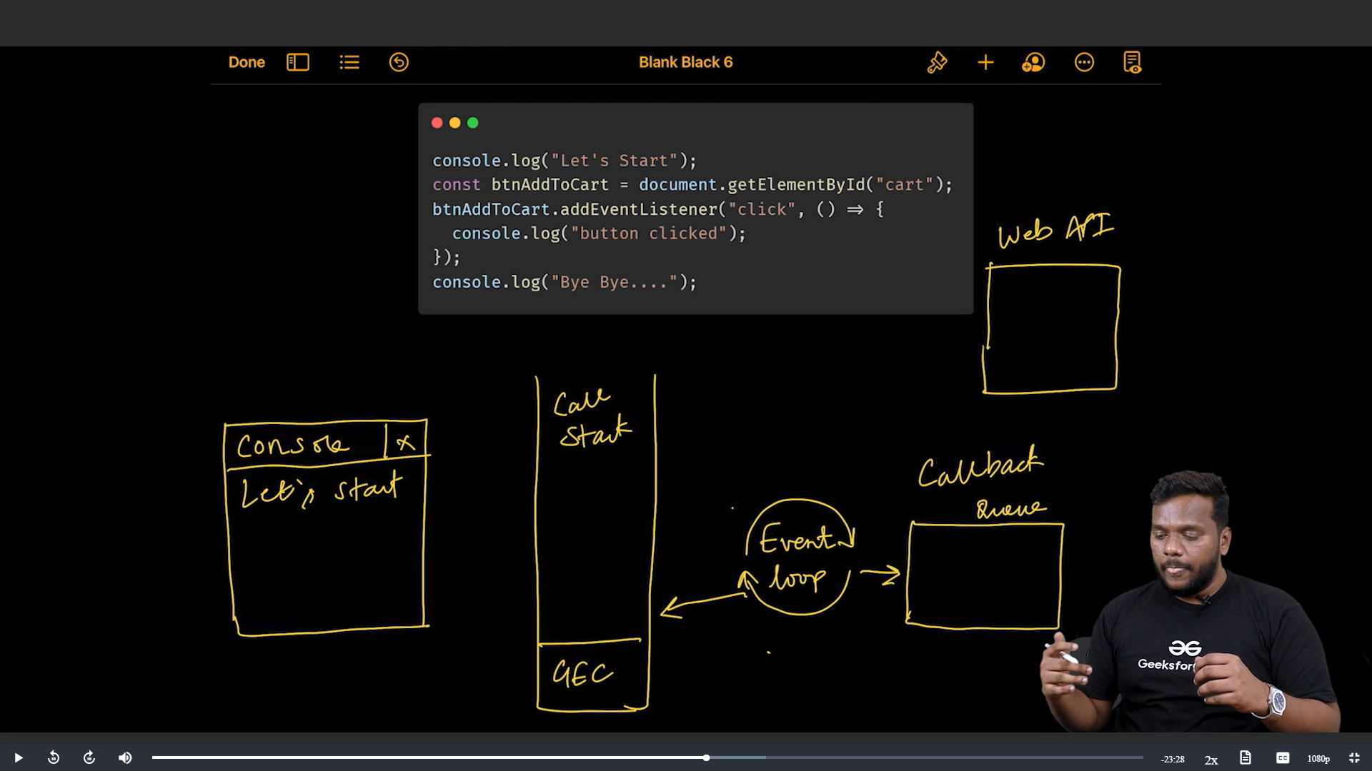

Later a click event is created inside the Web API.

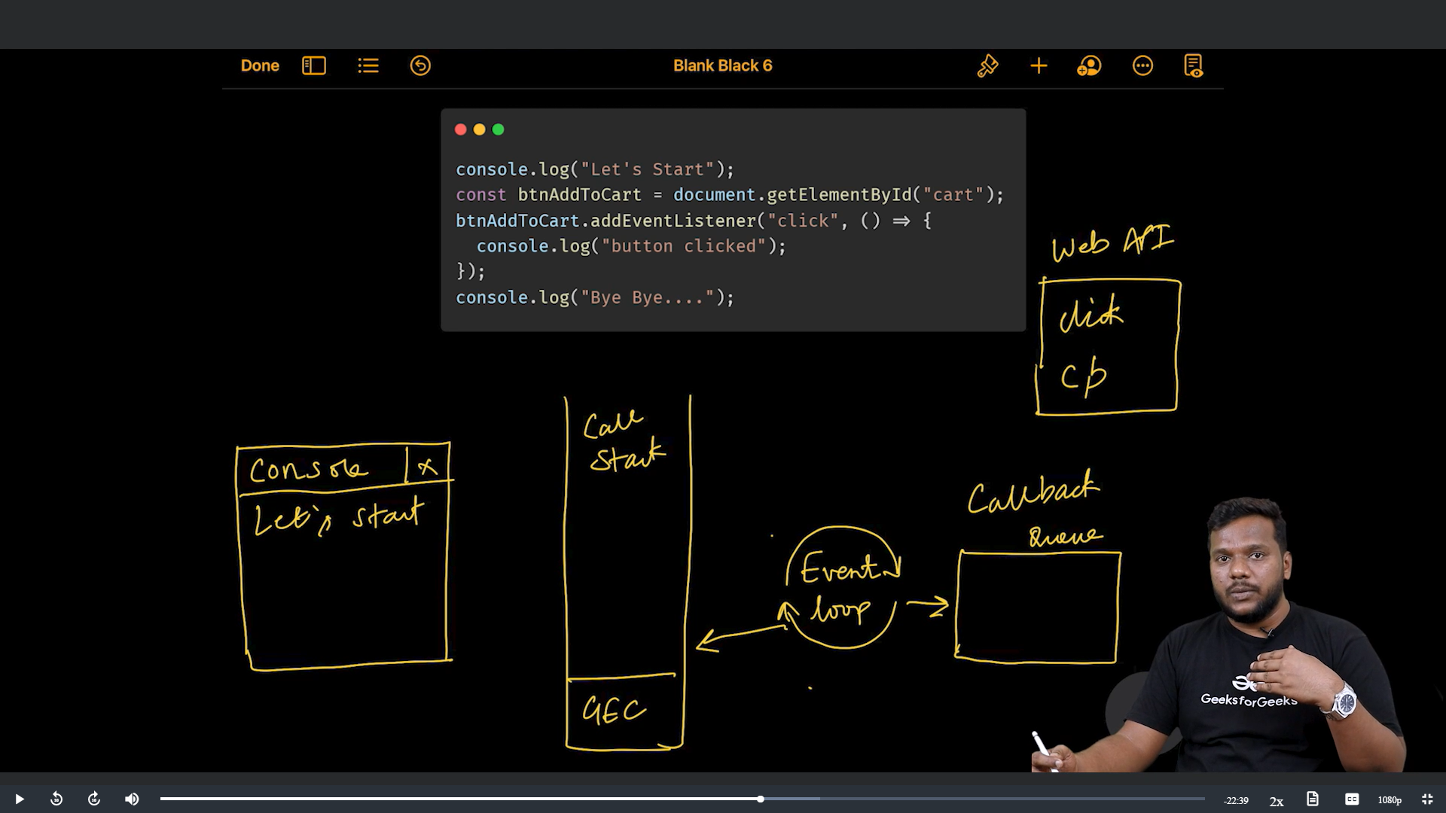

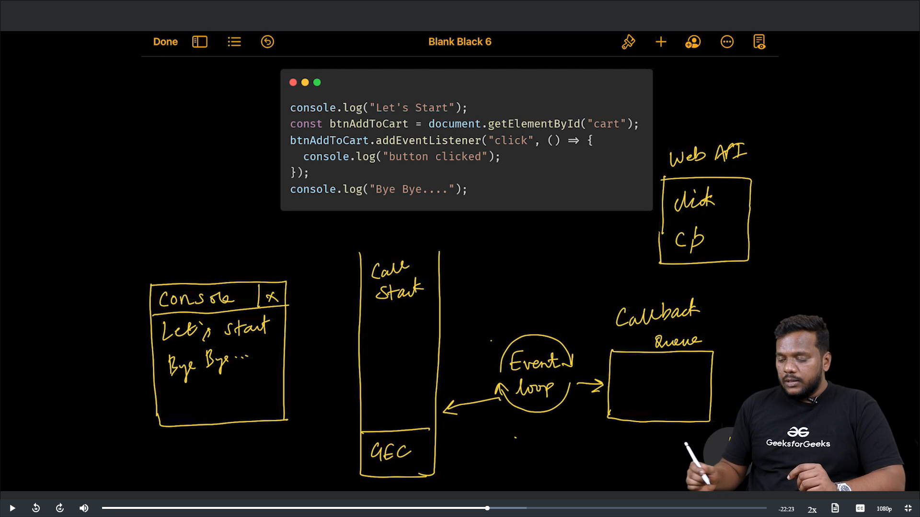

After this the GEC will be deleted.

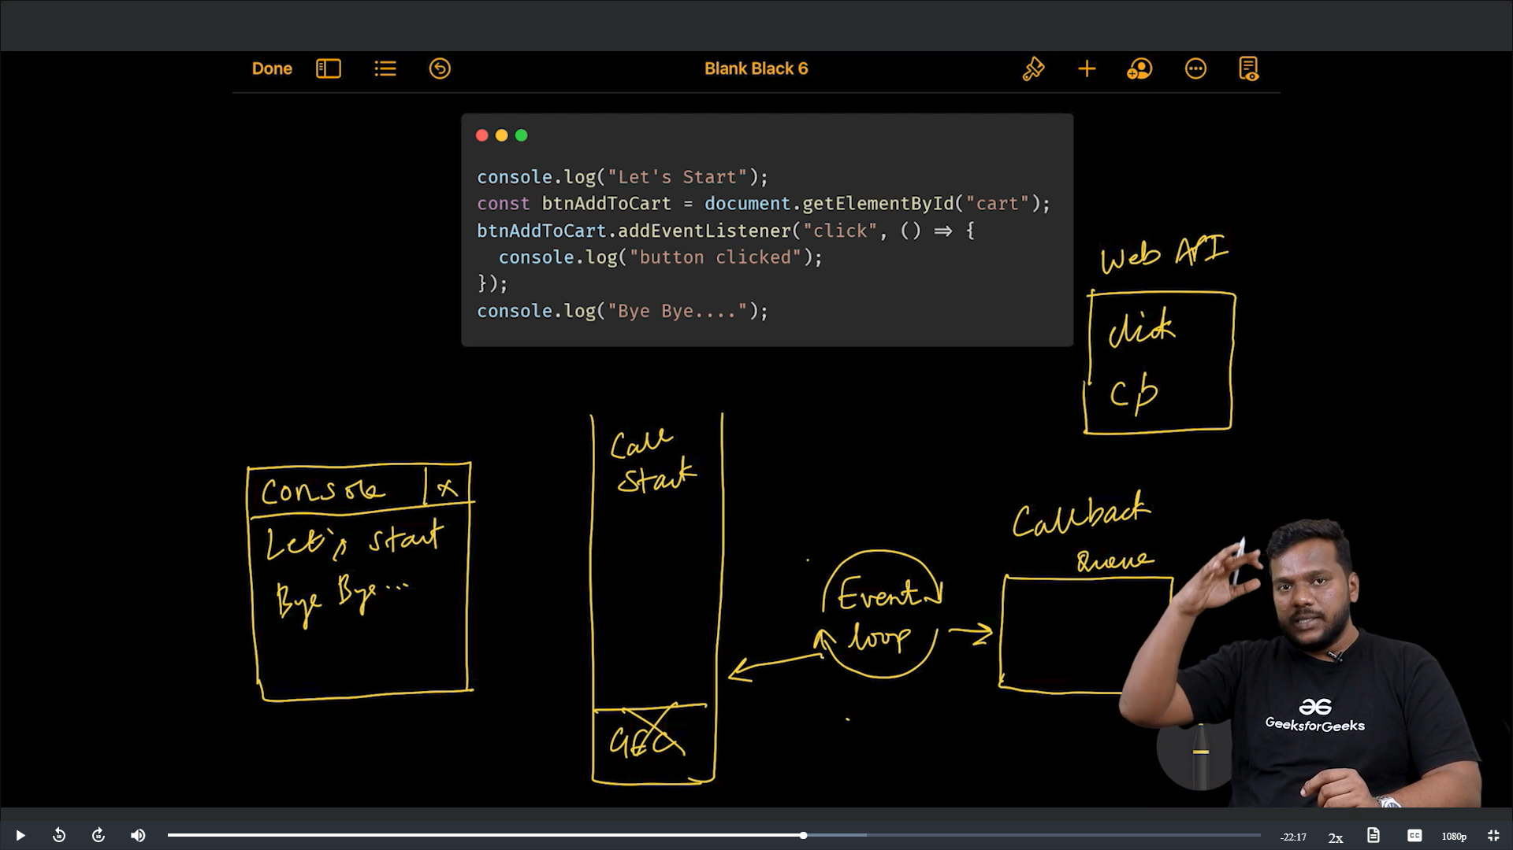

When the user clicked the button that click callback function present in Web API will enter Callback queue. After that Event Loop will check the call stack as it is empty. Callback function present in callback queue will enter into call stack and it will be executed as it is executed we can see that (Button Clicked) output.

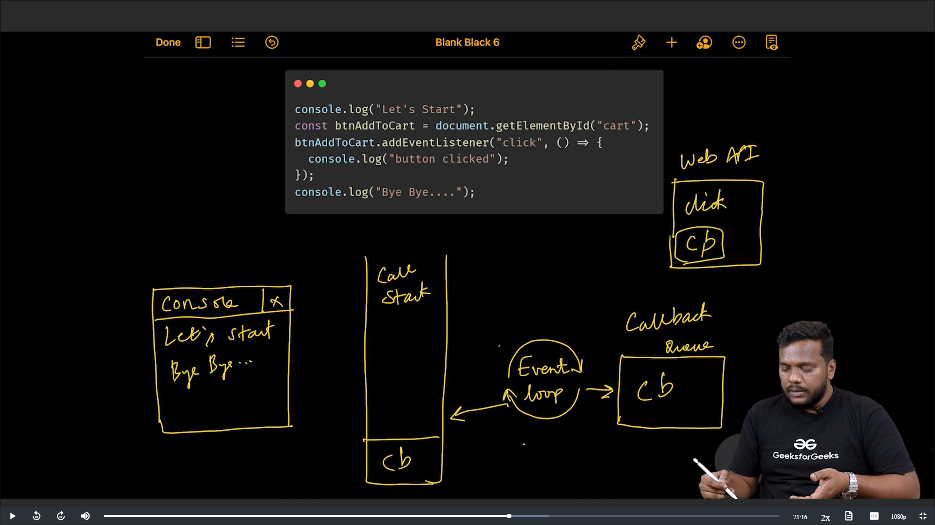

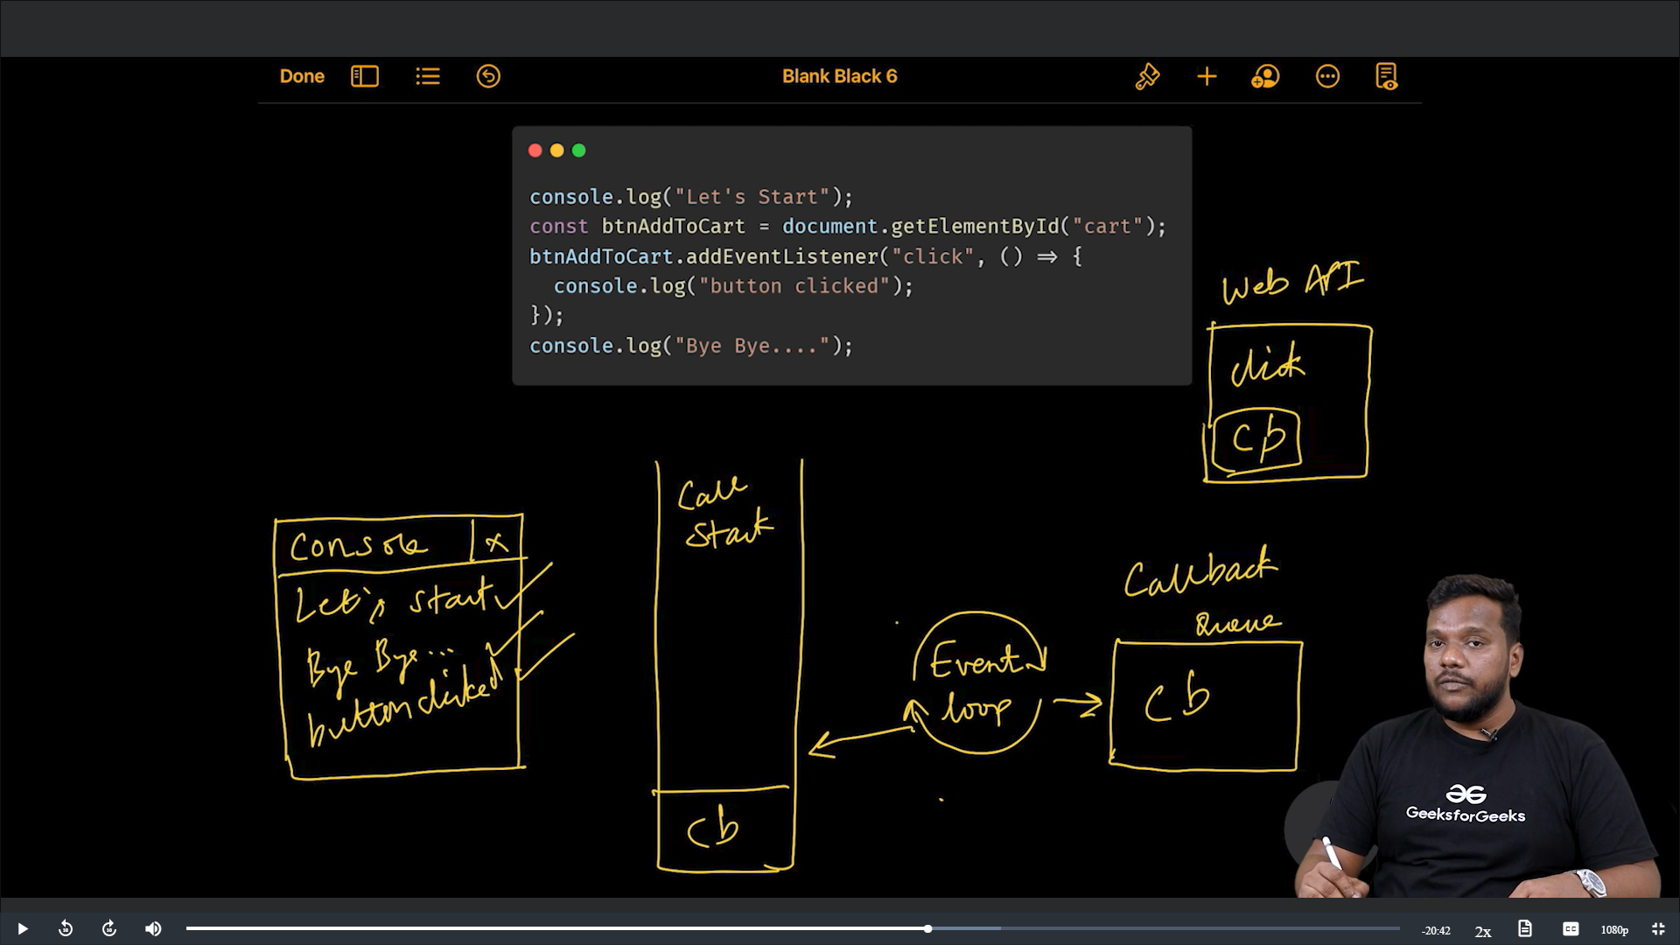

Example:

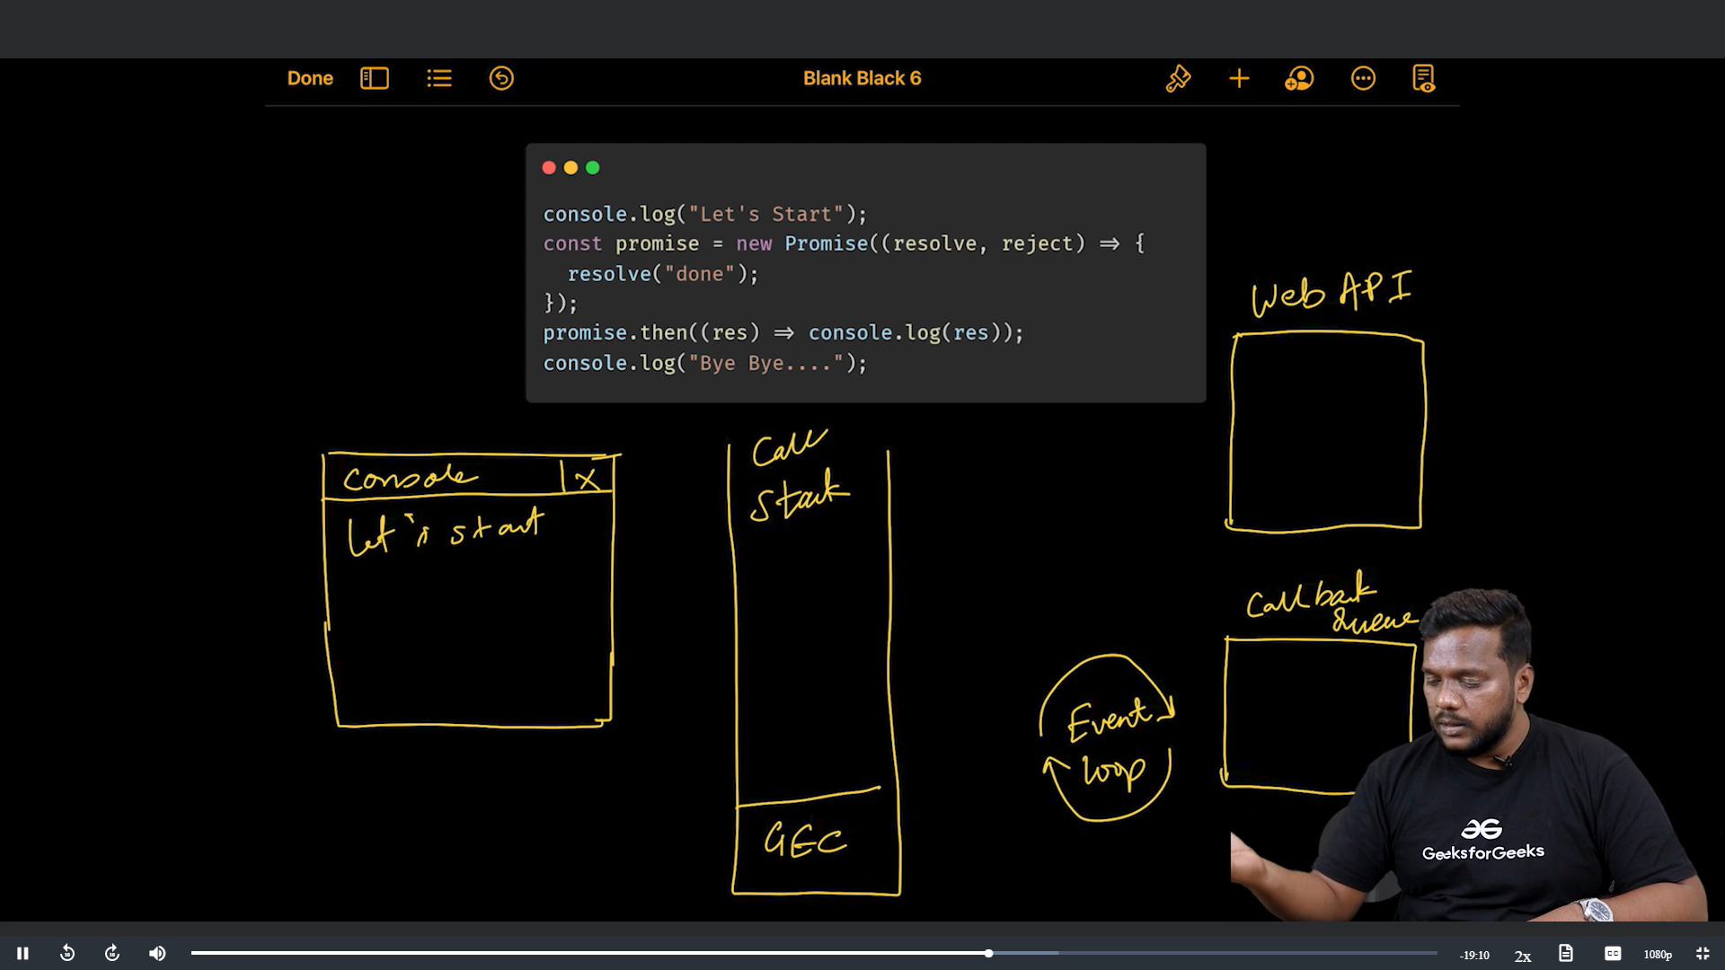

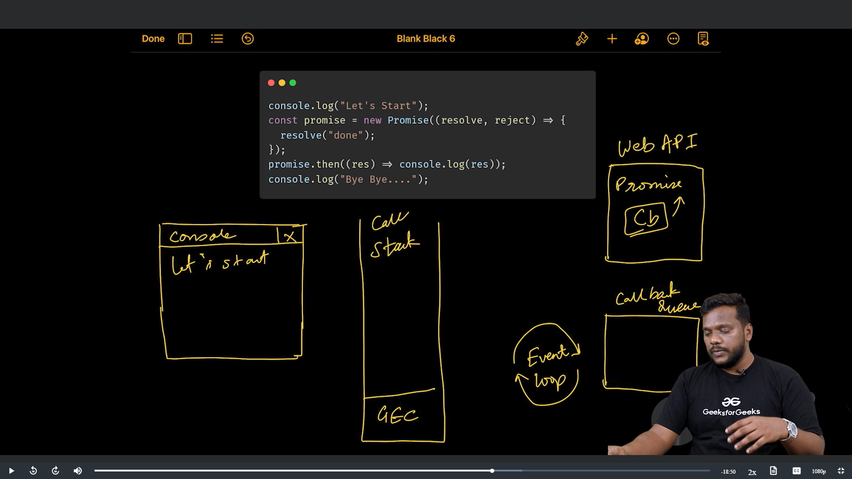

Here callback function means

promise.then((res) => console.log(res)); 🡪 this is the callback function.

When the promise is resolved this callback function will enter callback queue.

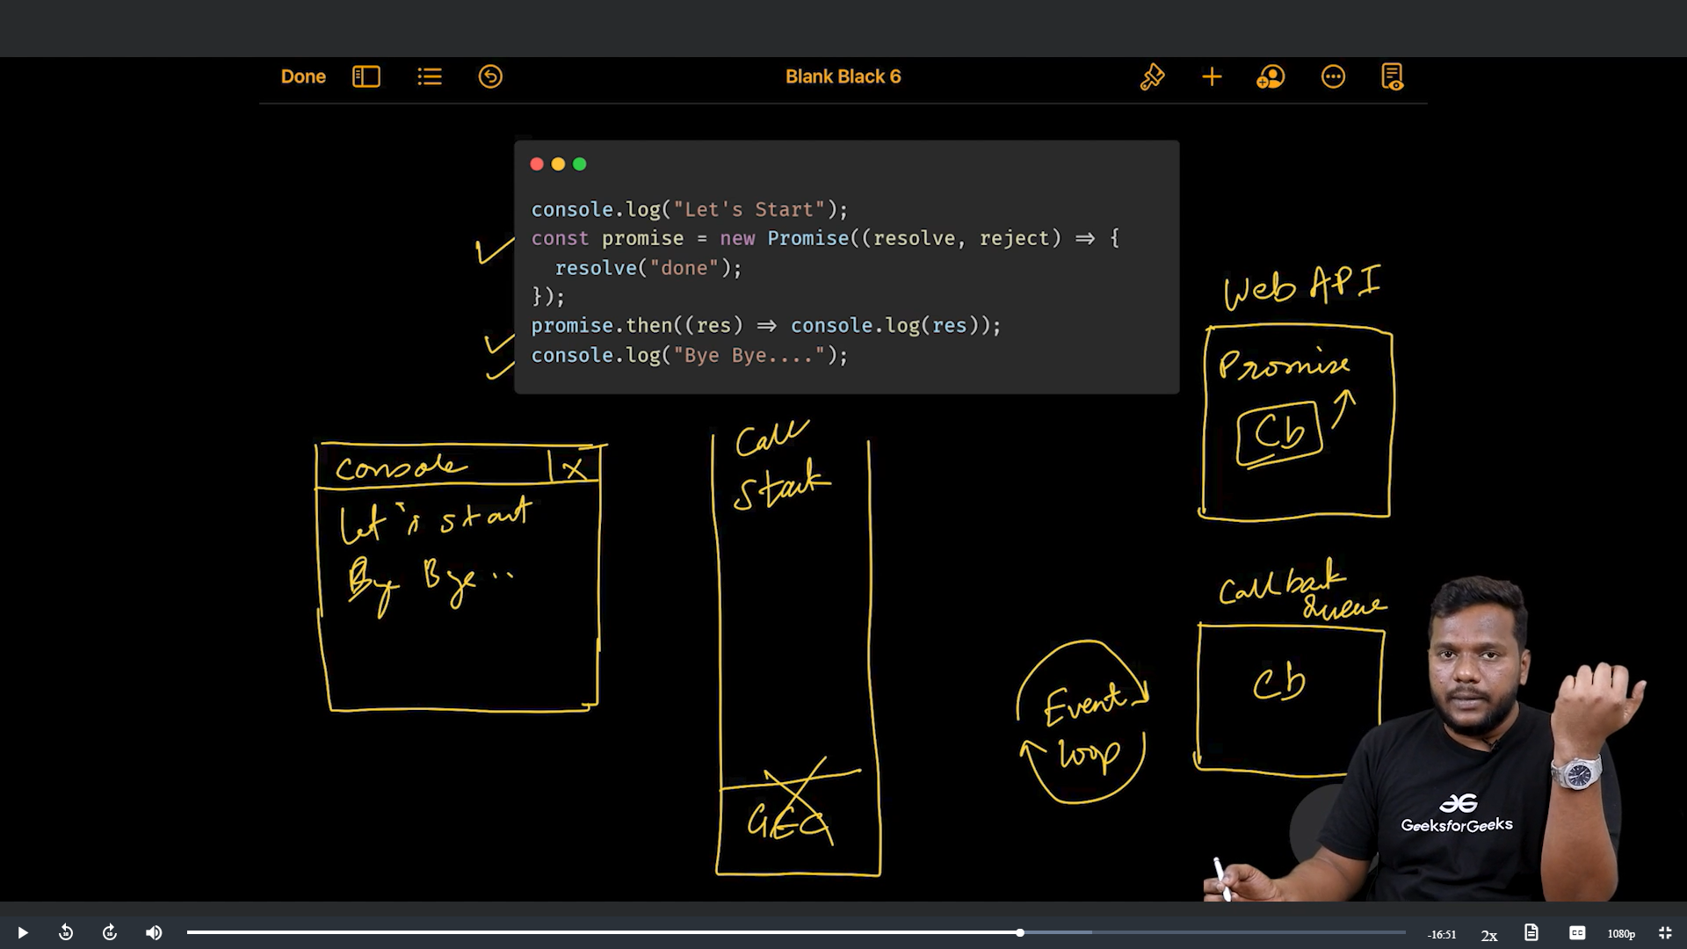

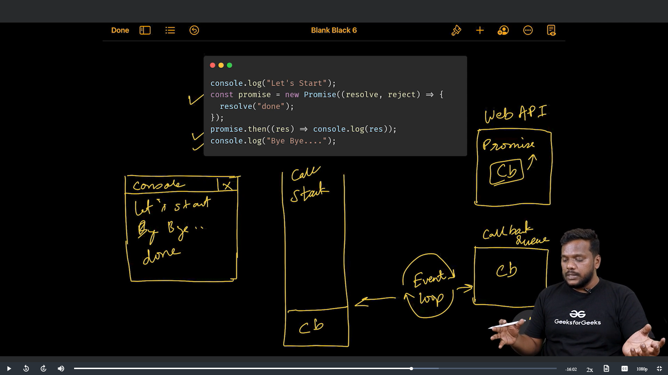

At last, this callback created inside call stack also deleted.

CALLBACK QUEUE

* This callback queue also consists of two parts—

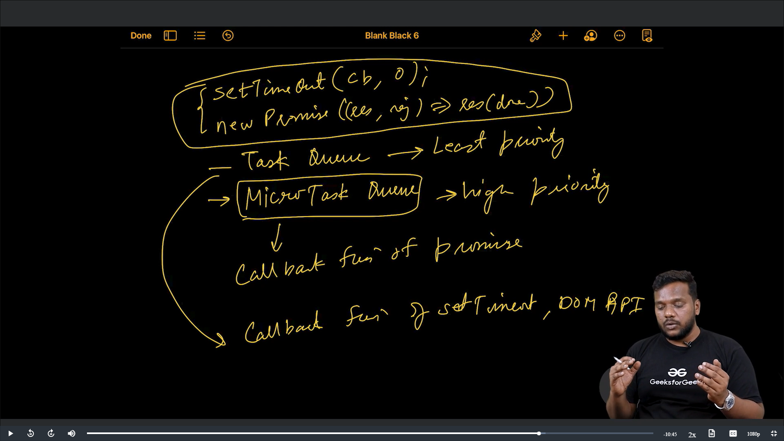

Whatever the task that came into the queue is not matter. The task of High priority (present in Micro Task Queue) is executed first.

Examples:

For clarity we can check in JS visualizer.

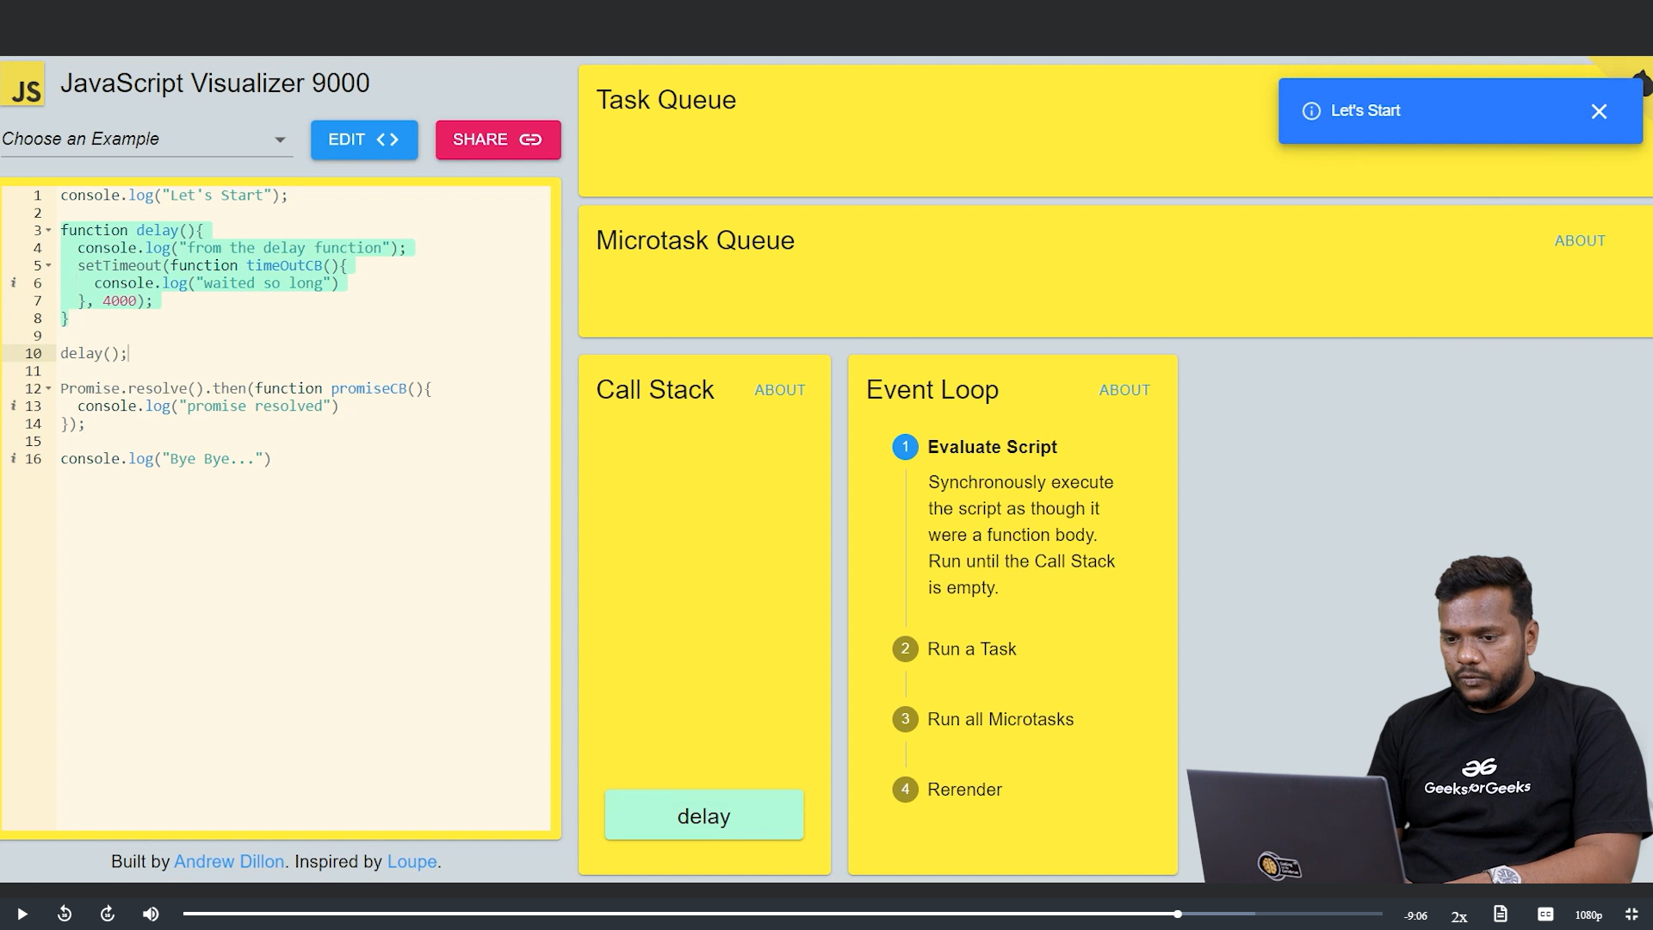

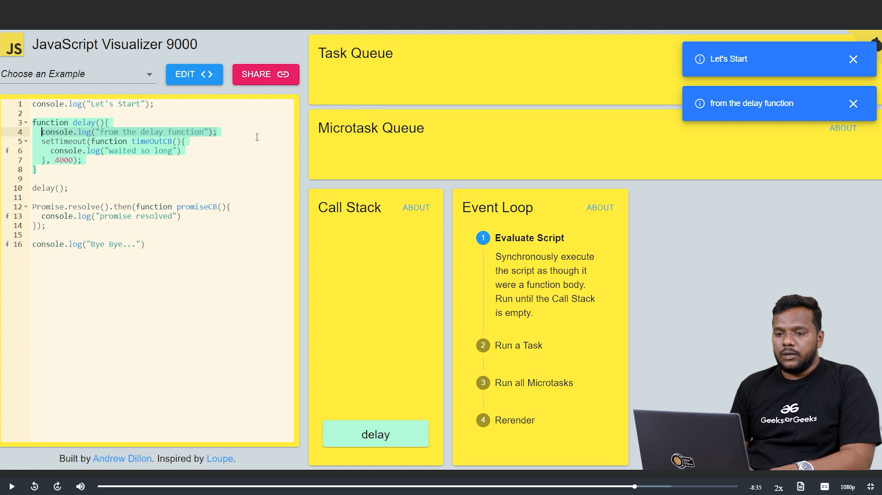

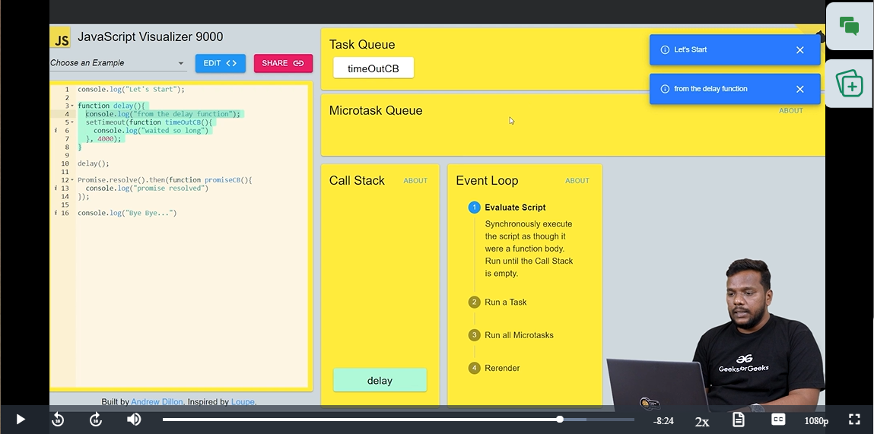

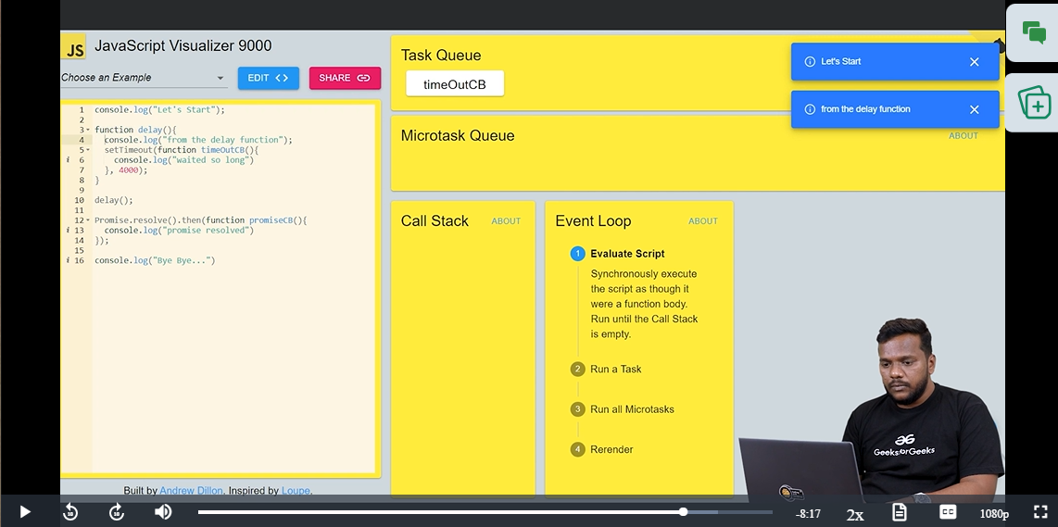

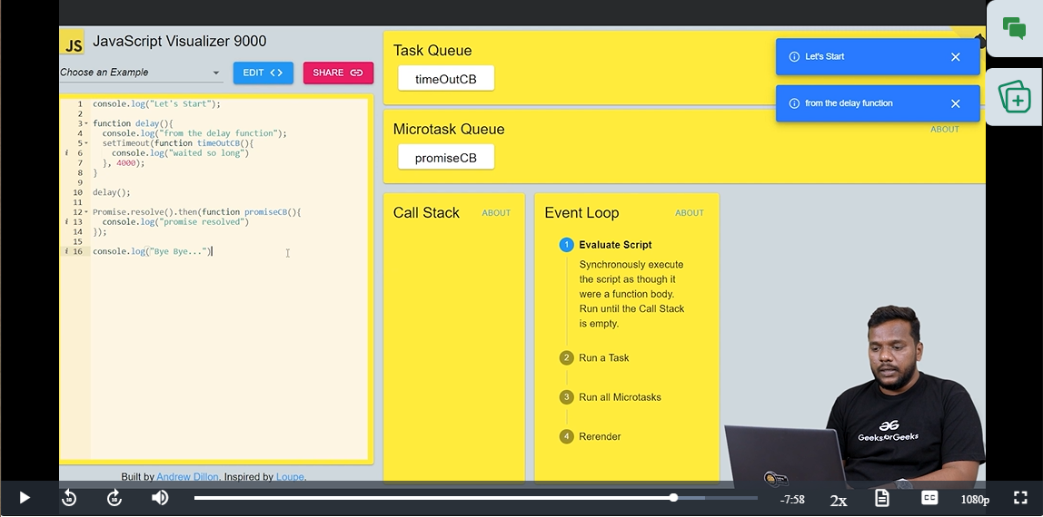

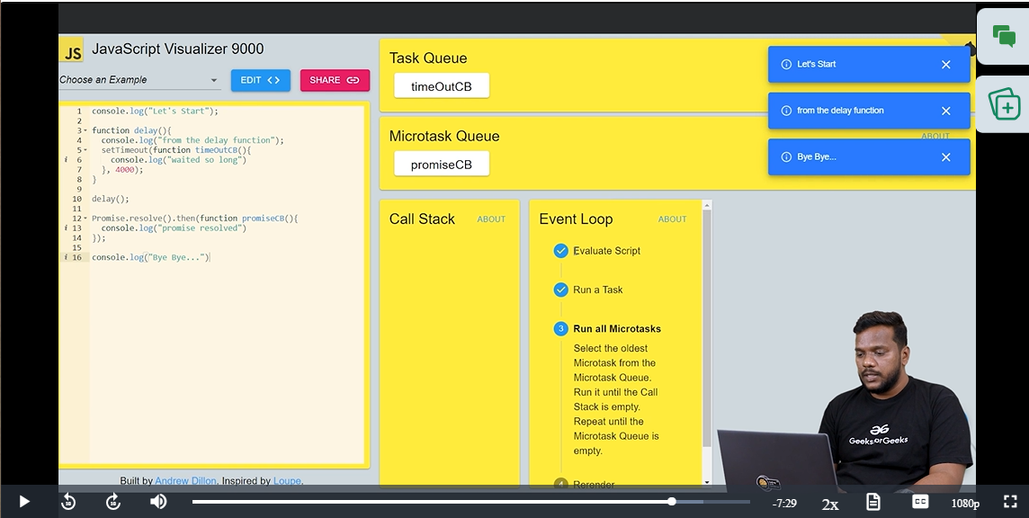

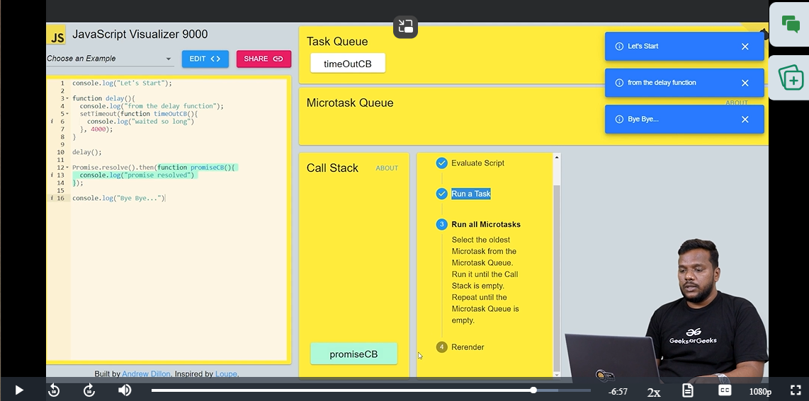

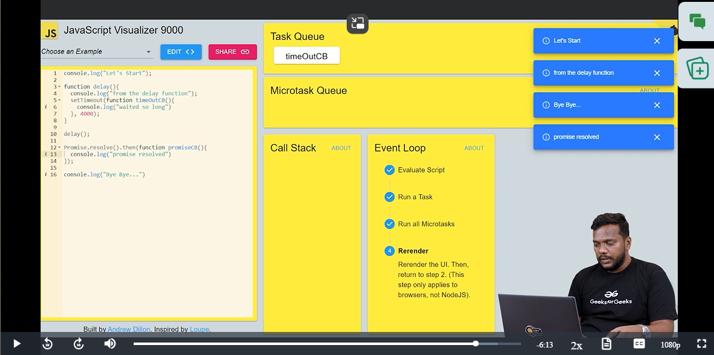

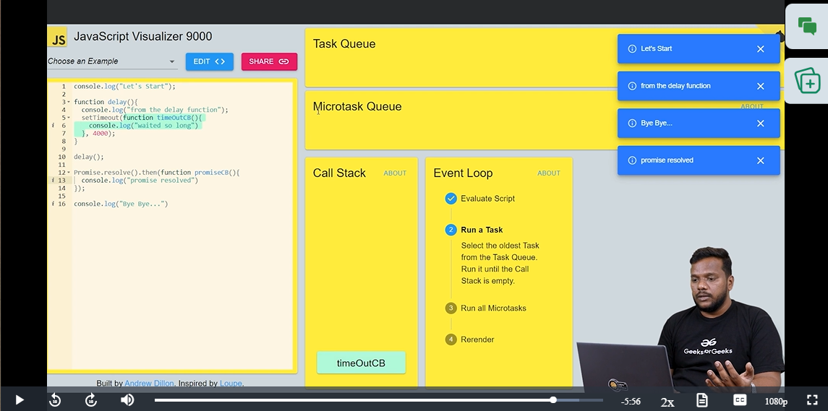

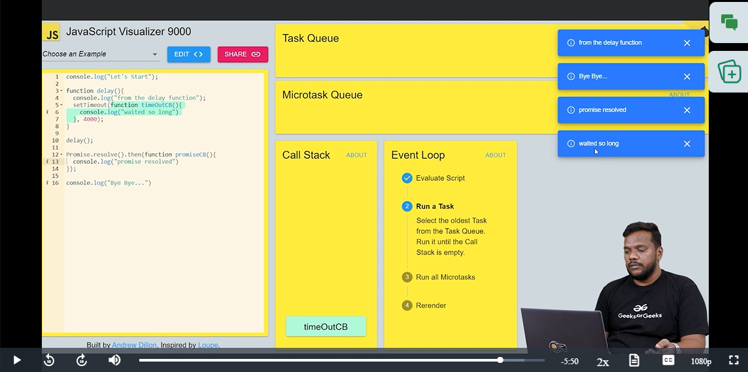

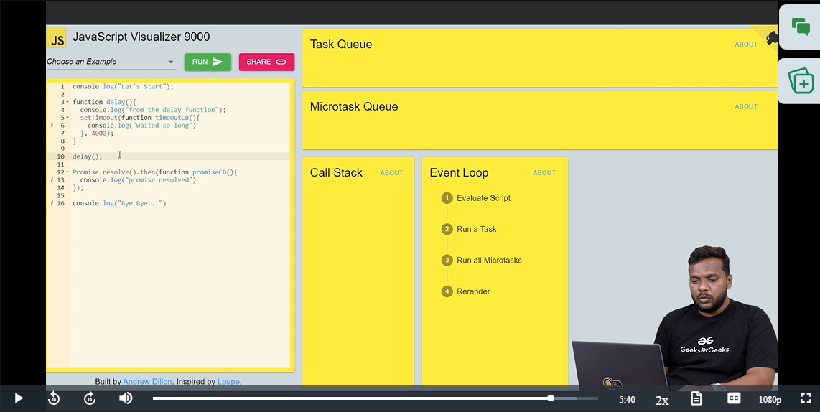

If we have two promises in our code then,

All will be same till this

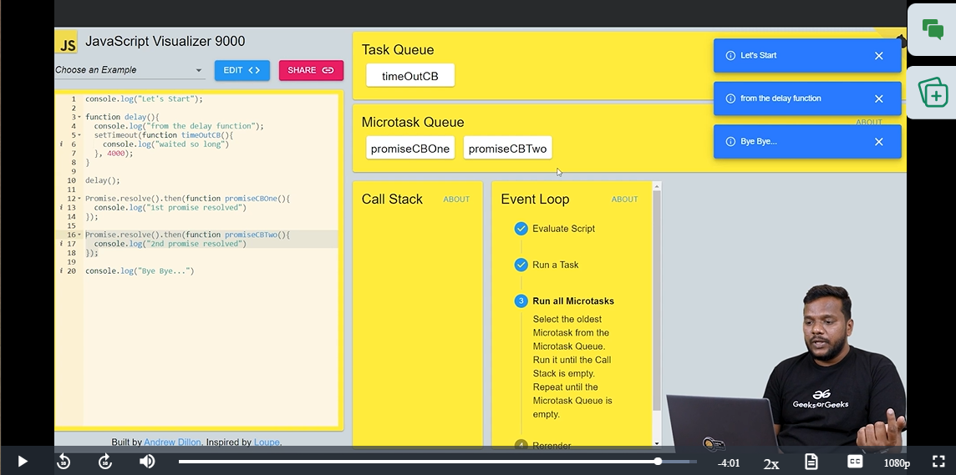

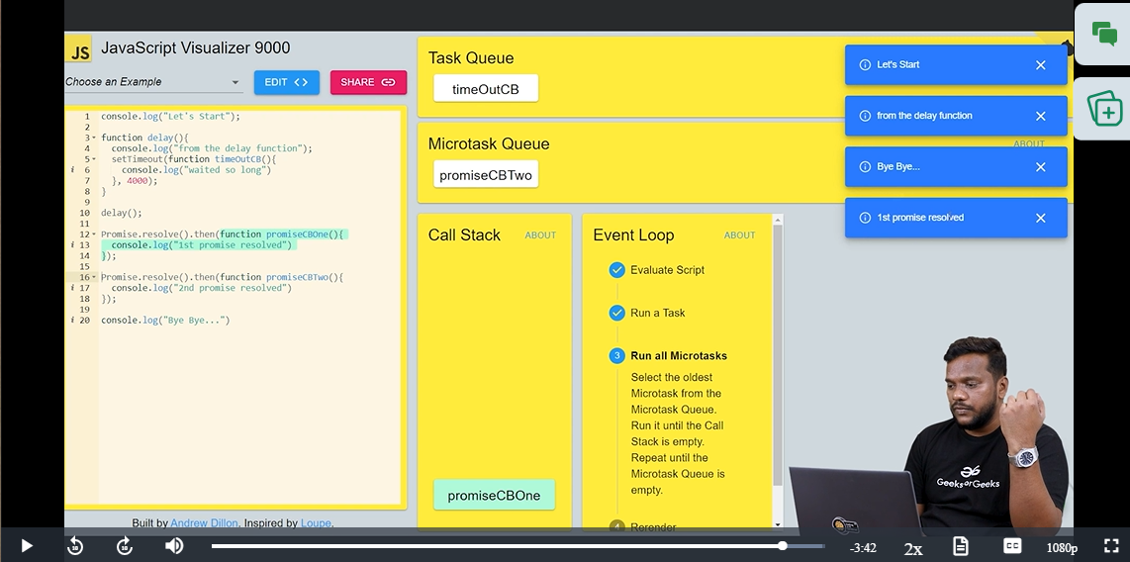

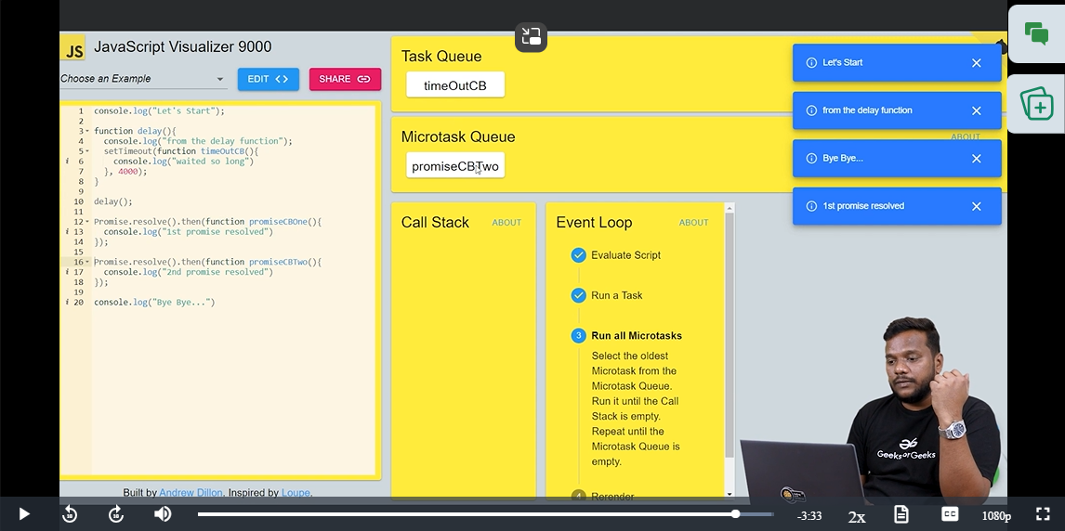  
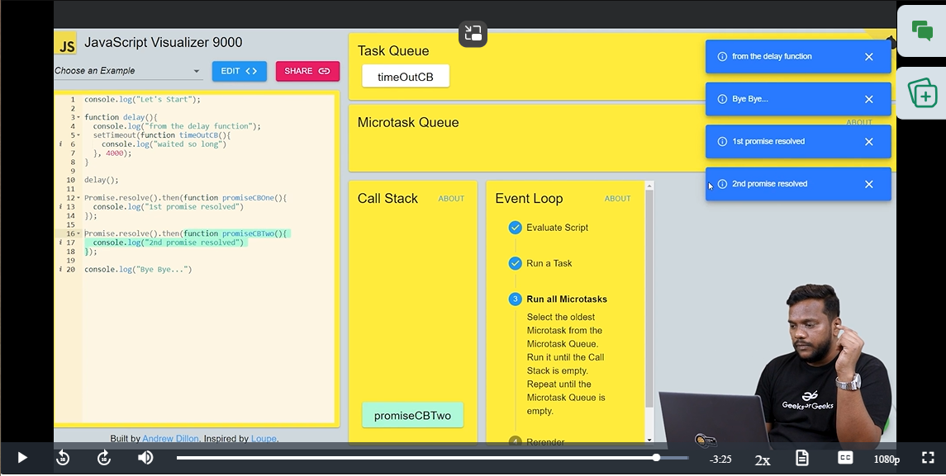

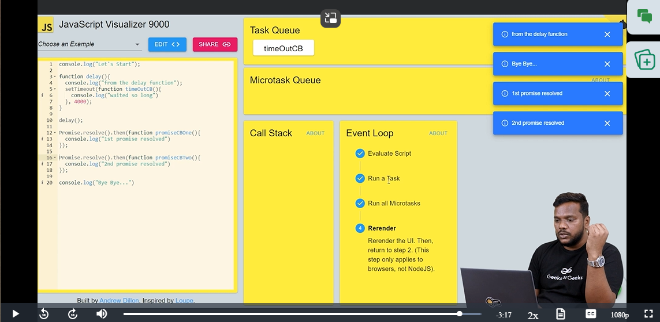

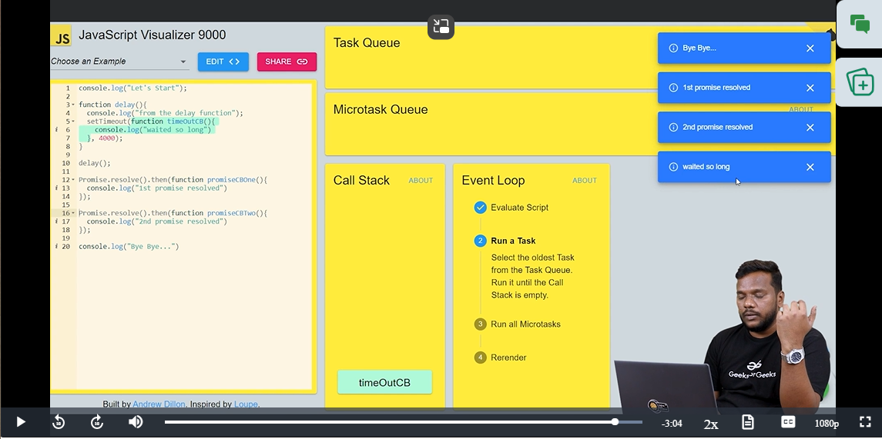

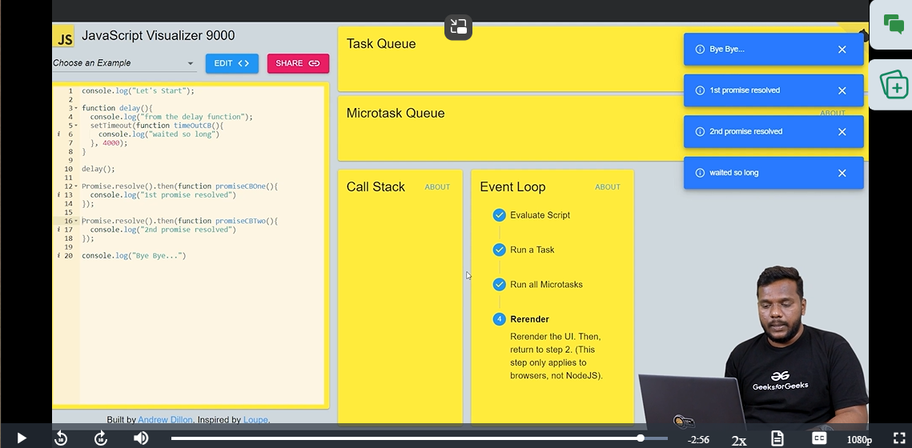

Whenever, we have a doubt we can check it in the visualizer like this.